**Description:**

This project includes generation of target where starting bits represents the number of zeros as per the difficulty level entered by the user and the rest of the bits are equal to 1’s.

Then the solution is randomly generated which after being hashed with input satisfies the condition

**hash(m||s)<=t**

Once the condition is being satisfied the loop will break and the solution is displayed in binary and BigInteger form.

1.As per the question the difficulty is being provided as 21to 26 and it is taking approximately 26 minutes to complete and get the result solution.

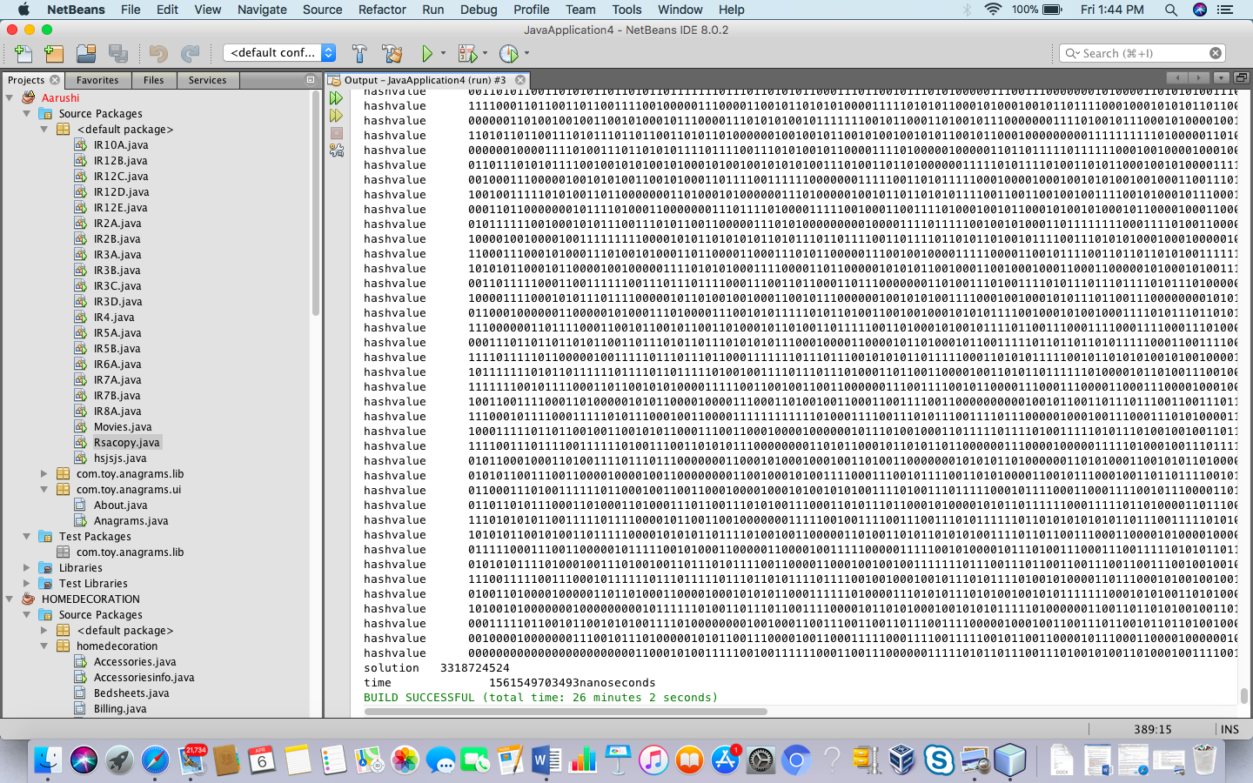

The project concentrates on generating random solution and checking whether that it is satisfying the condition that :

**H(m||s)<=t**

Once the condition is satisfied then the loop is broken and the solution Is written in form of bigInteger.

The packages used in this project are:

1. java.io.BufferedWriter: to write in the file.
2. java.io.FileInputStream: to read in the file.
3. java.io.FileWriter to write the file.
4. java.math.BigInteger to have biginteger to store hash value, solution
5. java.security.MessageDigest to implement SHA 256 to generate hash value.
6. java.util.Random to have random number.
7. java.util.Scanner to take difficulty input.

Configurations

This project is being made in java 8 and the OS used is MAC.

The Operating System used is MAC

java version "1.8.0_144"

Java(TM) SE Runtime Environment (build 1.8.0_144-b01)

Java Hotspot(TM) 64-Bit Server VM (build 25.144-b01, mixed mode).

The parameters you require are:

The string to hold the input from file, randomly generated solution and finding hash value. Target to be of 256 bit length where starting bit represents number of 0’s as per the value of difficulty level entered by user and rest of the bits are 1’s.